PROJECT REPORT

# 1.INTRODUCTION

1.1 Project Overview

**Title:** Comprehensive Analysis and Dietary Strategies with Tableau: A College Food Choices Case Study

**Objective:**

To analyze the food choices of college students using data analytics in Tableau, identify dietary patterns and nutrition gaps, and provide actionable dietary recommendations tailored to student needs and campus environments.

**Scope:**

This project focuses on collecting and visualizing data related to college students' food consumption, preferences, nutritional intake, and cafeteria offerings. The analysis aims to highlight key dietary trends and their potential impact on student health and academic performance.

**Key Goals:**

* Gather survey and cafeteria data on student food consumption.
* Use Tableau to perform visual analysis of dietary patterns.
* Identify common nutritional deficiencies or unhealthy habits.
* Recommend evidence-based dietary strategies for improvement.
* Present findings in interactive dashboards for stakeholders.

**Tools and Technologies:**

* Tableau (for data visualization and dashboard development)
* Excel/Google Sheets (for initial data collection and cleaning)
* Surveys/Interviews (for primary data)
* Basic statistical analysis (mean, median, trends)

**Target Audience:**

* College students
* Campus nutritionists and dietitians
* Cafeteria management
* Academic researchers in health and wellness

**Expected Outcome:**

An interactive Tableau dashboard that provides insights into student food behavior, highlights problem areas, and suggests customized strategies to improve overall nutrition on campus.

1.2 Purpose

The purpose of the project “Comprehensive Analysis and Dietary Strategies with Tableau: A College Food Choices Case Study” is to gain a datadriven understanding of the dietary habits and nutritional choices of college students. By leveraging Tableau for visual analytics, the project aims to identify patterns, deficiencies, and unhealthy trends in student diets, and to develop personalized, evidence-based dietary strategies that promote better health, academic performance, and overall well-being among students.

This project serves to:

* Enhance awareness of student nutrition issues.
* Provide clear, visual insights to inform decision-making.
* Support campus stakeholders in improving food services.
* Encourage healthier food choices through data storytelling.

# 2.IDEATION PHASE

2.1 Problem Statement

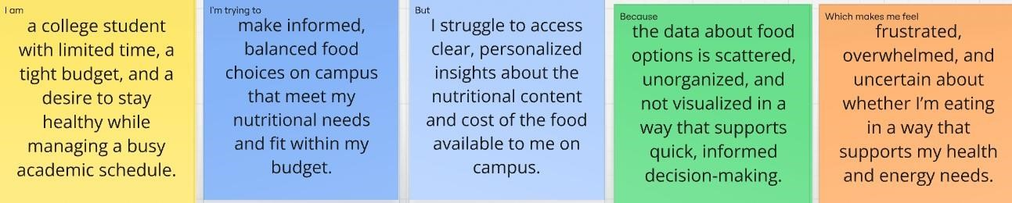

|  |  |  |  |  |  |
| --- | --- | --- | --- | --- | --- |
| **Problem**  **Statement (PS)** | **I am** | **I’m trying to** | **But** | **Because** | **Which makes me feel** |
| PS-1 | a college student with limited time, a tight budget, and a desire to stay healthy while managing a busy academic schedule. | make informed, balanced food choices on campus that meet my nutritional needs and fit within my budget. | I struggle to access clear, personalized insights about the nutritional content and cost of the food available to me on campus. | the data about food options is scattered, unorganized, and not visualized in a way that supports quick, informed decision making. | frustrated, overwhelmed, and uncertain about whether I’m eating in a way that supports my health and energy needs. |
| PS-2 | a university nutritionist responsible for supporting student health through meal planning and education. | identify patterns in student food choices to design better dietary strategies and recommend  healthier, more appealing meal options. | I can’t easily track or analyze large volumes of meal data or student preferences in a visual, actionable format. | the data is stored in multiple systems and lacks real time visualization tools that can reveal trends or problem areas. | ineffective, concerned, and unable to confidently support students with data driven dietary guidance. |

2.2 Empathy Map Convas

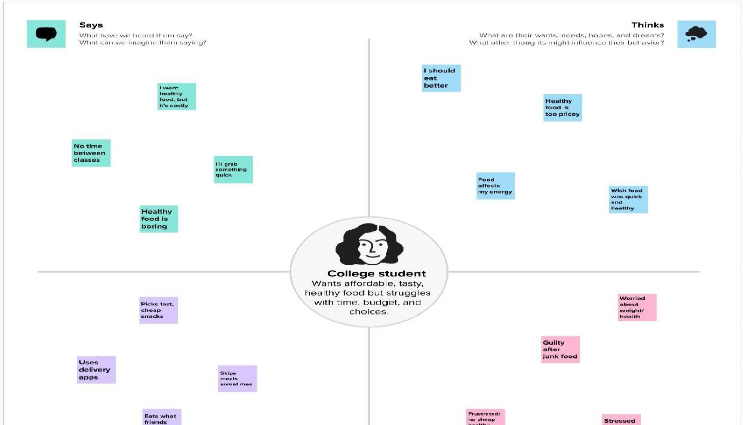

2.3 Branstroming

## Step-1: Team Gathring, Collaboration and Select the Problem Statement

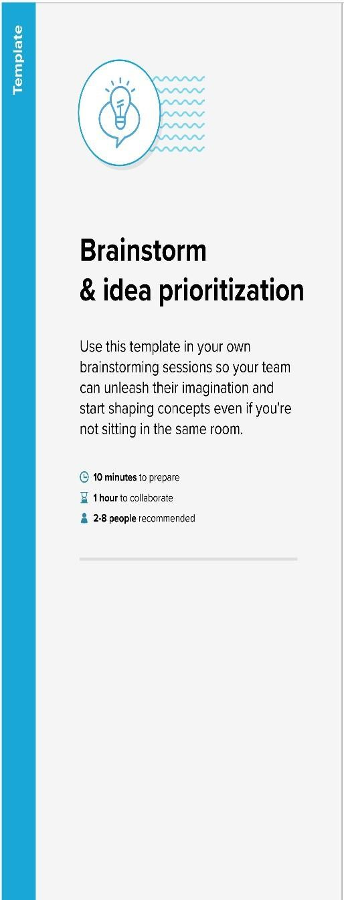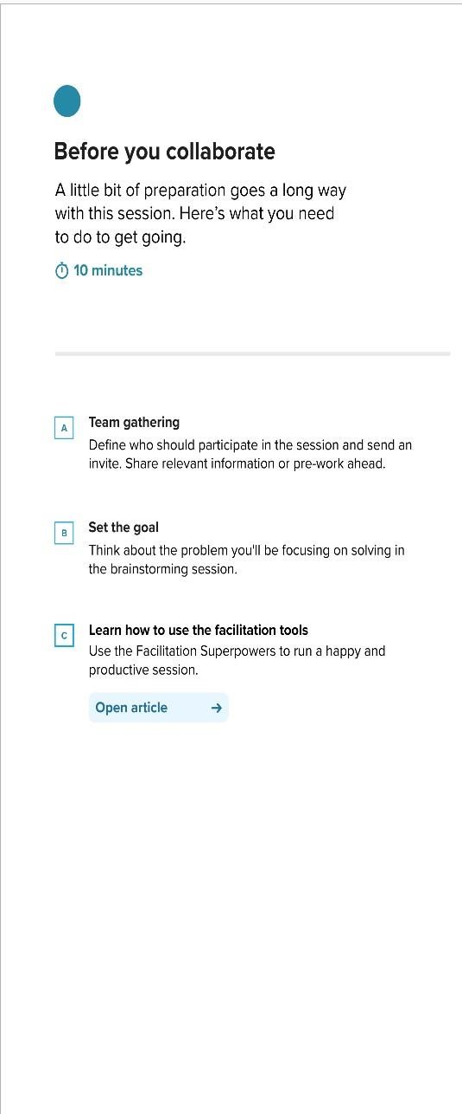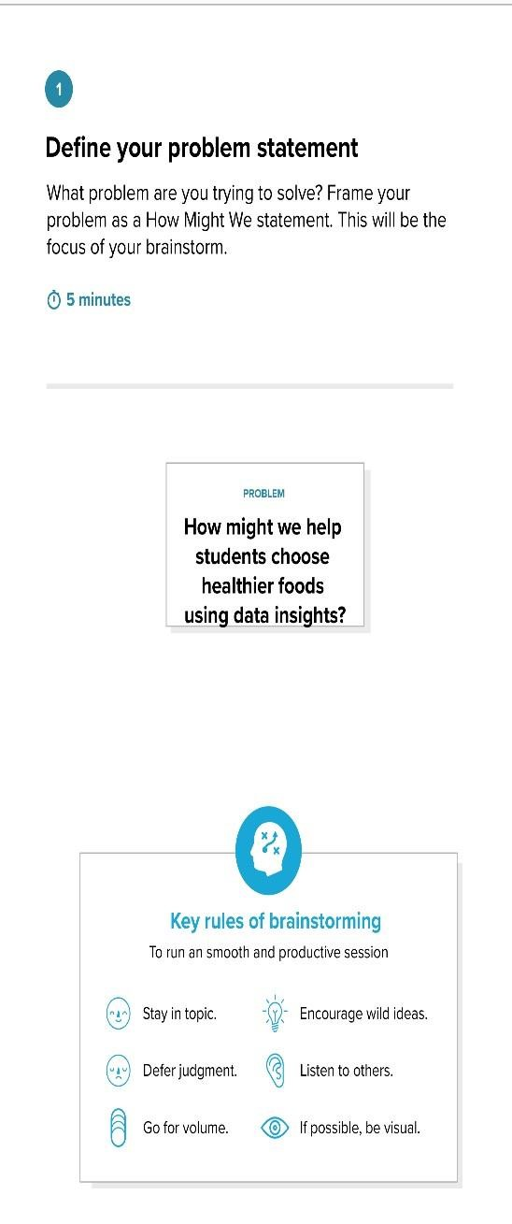

**Step-2: Brainstorm, Idea Listing and Grouping**

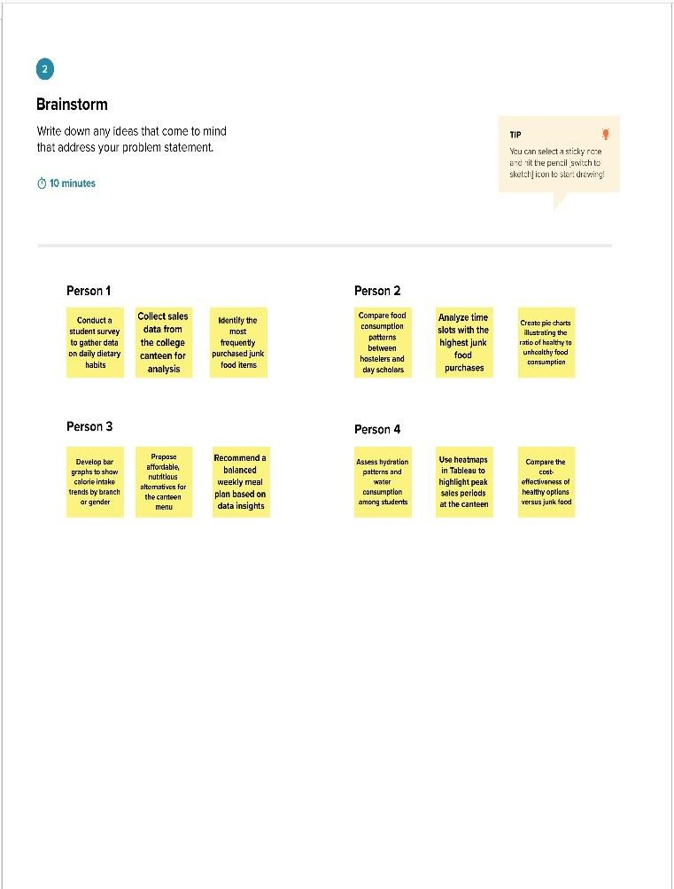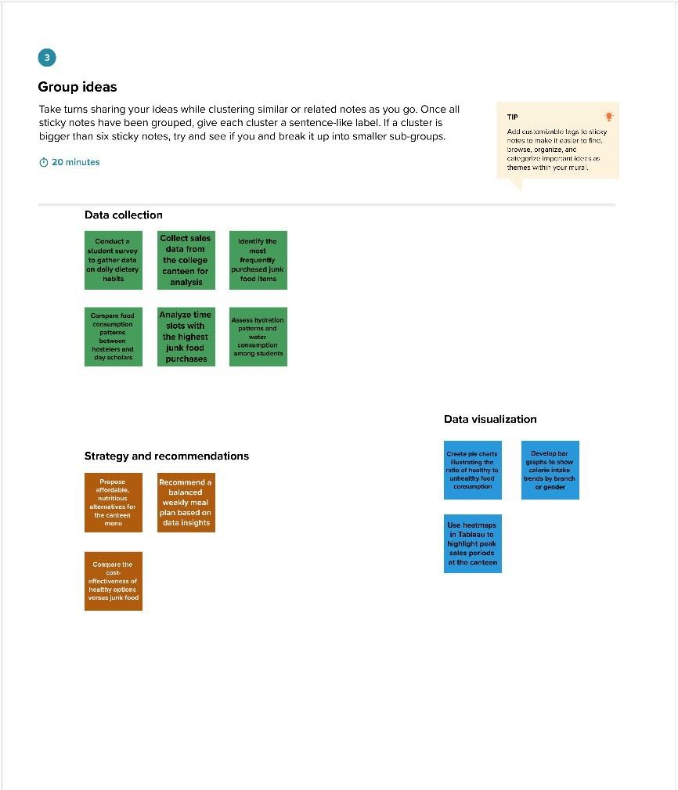

**Step-3: Idea Prioritization**

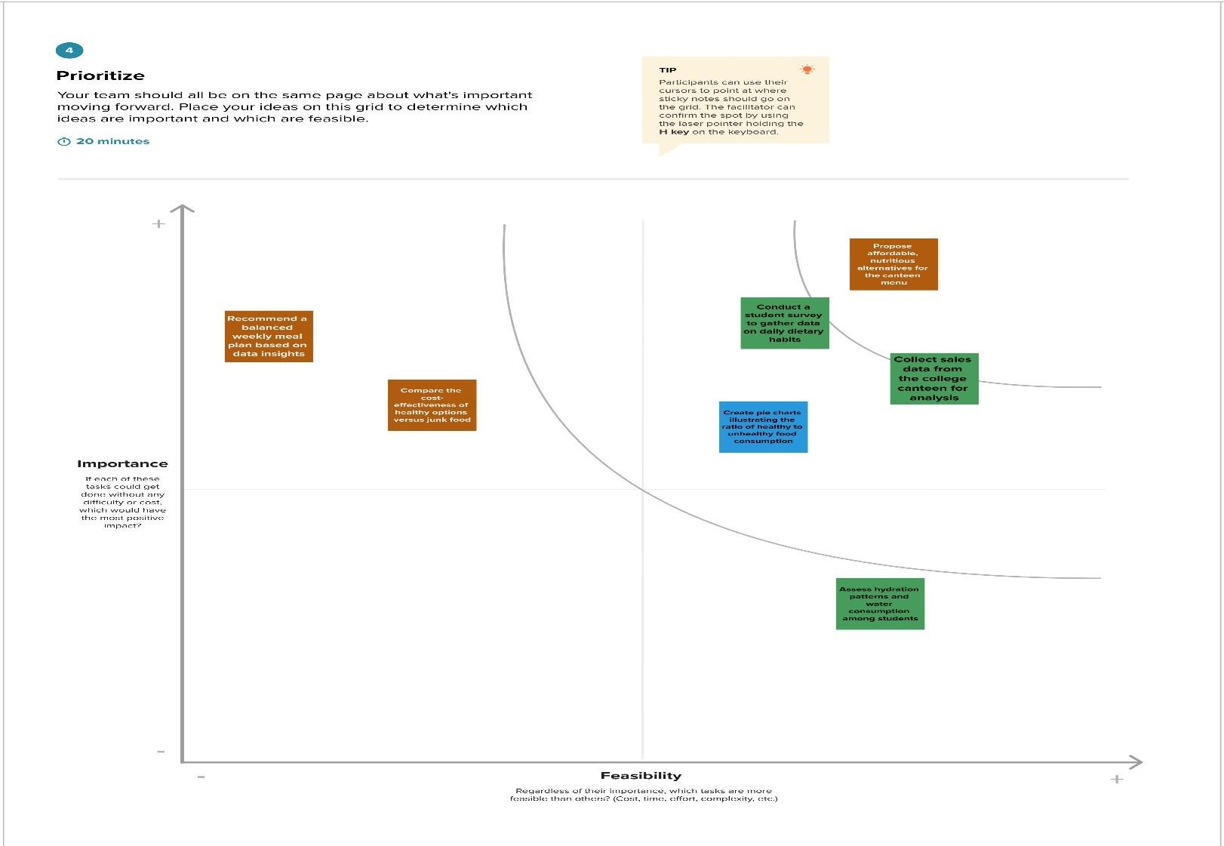

# 3.REQUIREMENT ANALYSIS

3.1 Customer Journey map

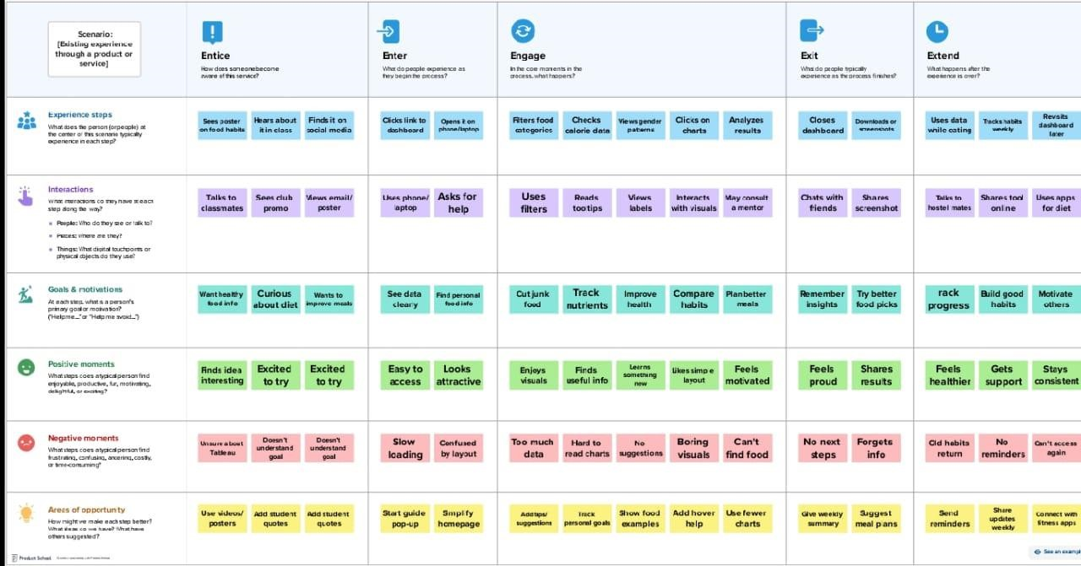

3.2 Solution Requirement

**Functional Requirements:**

Following are the functional requirements of the proposed solution.

|  |  |  |
| --- | --- | --- |
| **FR No.** | **Functional Requirement (Epic)** | **Sub Requirement (Story / Sub-Task)** |
| FR-1 | Data Collection | Collect food consumption data from students via online surveys or forms |
| FR-2 | Data Integration | Import data into Tableau from Excel, Google Sheets, or SQL databases |
| FR-3 | Data Visualization | Create charts and dashboards (e.g., calorie intake trends, food type frequency) |
| FR-4 | Nutritional Analysis | Analyze data to assess nutrient balance, deficiencies, and dietary patterns |
| FR-5 | Personalized Dietary Suggestions | Provide food recommendations based on user input or analysis output |
| FR-6 | Filtering and Interactivity | Allow users to filter results by age, gender, meal type, or location |
| FR-7 | Report Generation | Generate downloadable PDF/Excel reports on individual and group food habits |

**Non-functional Requirements:**

Following are the non-functional requirements of the proposed solution.

|  |  |  |
| --- | --- | --- |
| **FR No.** | **Non-Functional Requirement** | **Description** |
| NFR-1 | **Usability** | Dashboards should be user-friendly and easy to navigate for non-technical users |
| NFR-2 | **Security** | SecurityEnsure data privacy for individual food records and personal |
| NFR-3 | **Reliability** | System should consistently produce accurate analysis and insights |
| NFR-4 | **Performance** | Dashboards should load within 3 seconds even with large datasets |
| NFR-5 | **Availability** | System should be accessible 24/7 during the research period |
| NFR-6 | **Scalability** | Should support increasing users/data volume as more colleges join the study |

3.3 Data Flow Diagram

**User Stories**



**Example**

[**:**](https://developer.ibm.com/patterns/visualize-unstructured-text/)



[**(**](https://developer.ibm.com/patterns/visualize-unstructured-text/)



[**S**](https://developer.ibm.com/patterns/visualize-unstructured-text/)

[**implifie**](https://developer.ibm.com/patterns/visualize-unstructured-text/)

[**d**](https://developer.ibm.com/patterns/visualize-unstructured-text/)



[**)**](https://developer.ibm.com/patterns/visualize-unstructured-text/)

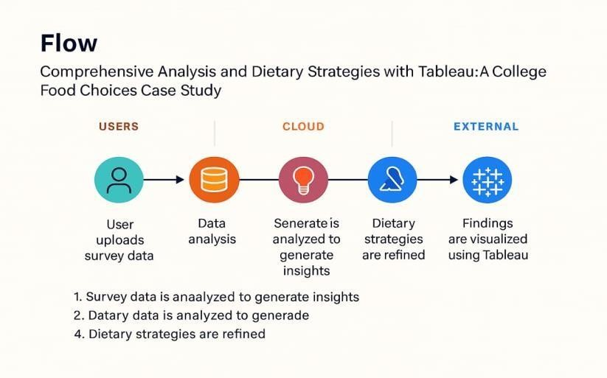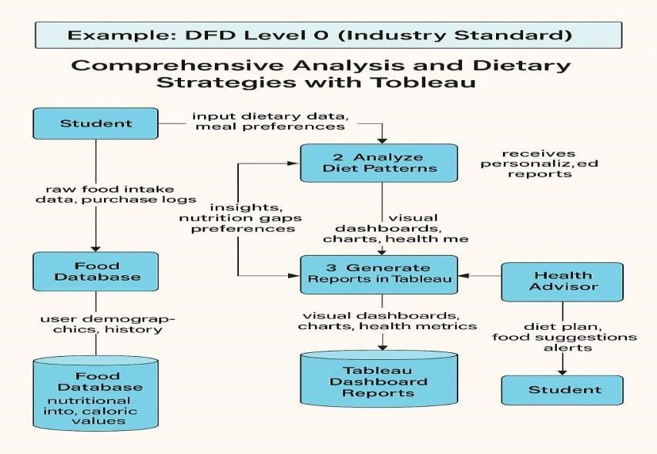

Use the below template to list all the user stories for the product.

|  |  |  |  |  |  |  |
| --- | --- | --- | --- | --- | --- | --- |
| **User Type** | **Functional**  **Requirement**  **(Epic)** | **User Story**  **Number** | **User Story / Task** | **Acceptance criteria** | **Priority** | **Release** |
| Student  (Mobile/Web) | Data Entry | USN-1 | As a student, I can input my daily meals including food items and quantities. | I can view and submit a completed meal entry form. | High | Sprint-1 |
| Student  (Mobile/Web) | Visualization Access | USN-2 | As a student, I can view a visual analysis of my weekly nutrition intake via Tableau dashboard.. | I can access charts showing my calorie and nutrient intake | High | Sprint-1 |
| Student  (Mobile/Web) | Comparison & Suggestions | USN-3 | As a student, I can compare my dietary intake to recommended guidelines and receive suggestions. | I receive personalized dietary tips based on my current intake. | Medium | Sprint-2 |
| Nutrition Expert | Data Analysis & Oversight | USN-4 | As a nutrition expert, I can review aggregated data from multiple students for analysis. | I can filter and download collective data for analysis. | High | Sprint-2 |
| College Admin | Reporting | USN-5 | As an admin, I can generate reports on dietary trends among student groups. | I can export reports showing trends, deficiencies, and participation rates. | Medium | Sprint-3 |
| Student | Goal Tracking | USN-6 | As a student, I can set personal dietary goals and track my progress over time. | I can view goal progress with visual indicators on my dashboard. | Low | Sprint-3 |
| Student | Feedback &  Recommendations | USN-7 | As a student, I can receive automatic feedback based on unhealthy food choices I log. | I see alert messages or tips when I log unhealthy meals. | Medium | Sprint-2 |
| Student | History Tracking | USN-8 | As a student, I can view a history of all my past meal entries and dietary feedback. | I can browse my past entries by date or week. | Medium | Sprint-2 |
| Nutrition Expert | Custom Rule Definition | USN-9 | As a nutrition expert, I can define custom dietary rules for students with different needs (e.g.,athletes).. | I can add and assign dietary rule sets to specific student categories | Low | Sprint-3 |
| College Admin | Participation Analytics | USN-10 | As an admin, I can view participation metrics by department, year, or gender. | I can filter participation reports by different demographics. | Low | Sprint-3 |

3.4 Technology stack

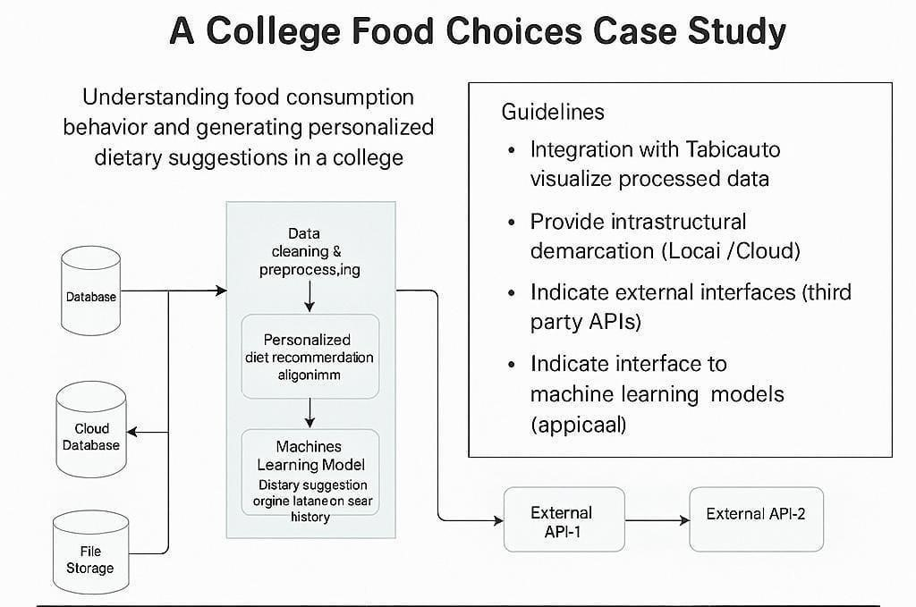

**Table-1 : Components & Technologies:**

|  |  |  |  |
| --- | --- | --- | --- |
| **S.No** | **Component** | **Description** | **Technology** |
| 1. | User Interface | How user interacts with application Dashboard,  Survey Input UI | Dashboard, Survey Input UI Tableau Dashboards, React.js, HTML/CSS |
| 2. | Application Logic-1 | Data collection logic (surveys, cafeteria logs, manual entries) | Python scripts, Tableau Web Data Connectors |
| 3. | Application Logic-2 | Data cleaning & preprocessing | Tableau Prep, Python (Pandas) |
| 4. | Application Logic-3 | Personalized diet recommendation algorithm | Python (scikit-learn), ML Models |
| 5. | Database | Storage of raw & processed dietary data | MySQL, NoSQL (MongoDB) |
| 6. | Cloud Database | Cloud-based access to dietary datasets | . Google Firebase, AWS RDS,  Snowflake |
| 7. | File Storage | Storing reports, charts, and user uploads | AWS S3, Google Drive API, Tableau Public |
| 8. | External API-1 | Nutrition data from external sources | USDA Food Data Central API |
| 9. | External API-2 | Student info or campus data access | College ERP API, Google Forms API |
| 10. | Machine Learning Model | Dietary suggestion engine based on user history | Python ML Model (KNN, Decision Tree) |
| 11. | Infrastructure (Server / Cloud) | Hosting Tableau server or cloud dashboards | Tableau Server, AWS EC2, Google Cloud. |

**Table-2: Application Characteristics:**

|  |  |  |  |
| --- | --- | --- | --- |
| **S.No** | **Characteristics** | **Description** | **Technology** |
| 1. | Open-Source Frameworks | List the open-source frameworks used | Python (Pandas, NumPy, scikit-learn), MySQL |
| 2. | Security Implementations | .Access control for student health data, APIs, and dashboards | OAuth 2.0, Encryption (SHA-256), IAM Roles |
| 3. | Scalable Architecture | Modular layers: UI – Processing – Storage – ML – Visualization | Microservices, Docker, Tableau Extensions |
| 4. | Availability | Hosted on cloud with dashboard backup, loadbalanced APIs | Tableau Online, Load Balancer (AWS/GCP) |
| 5. | Performance | Fast dashboard loading, efficient ML model execution, data caching | Tableau Extracts, CDN, Redis (optional) |

# 4.PROJECT DESIGN

4.1 Problem Solution Fit

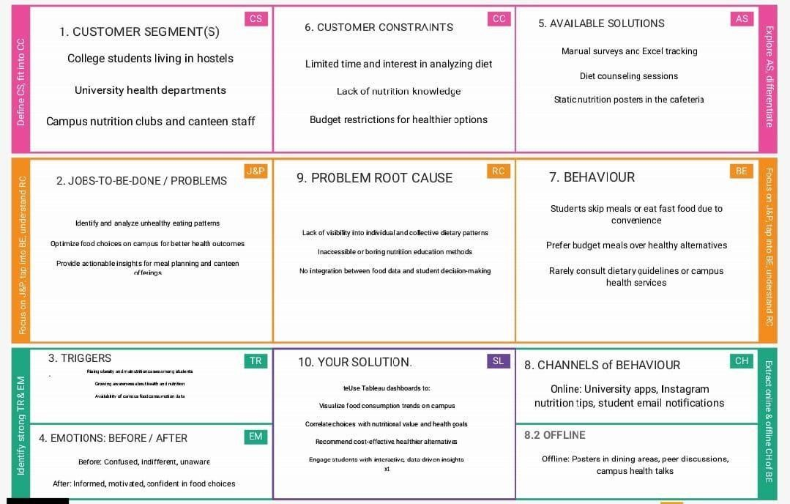

4.2 Proposed Solution

Project team shall fill the following information in the proposed solution template.

|  |  |  |
| --- | --- | --- |
| **S.No.** | **Parameter** | **Description** |
| 1. | Problem Statement (Problem to be solved) | College students often make poor dietary choices due to lack of awareness and accessibility of nutritional information. This leads to long-term health issues. |
| 2. | Idea / Solution description | Use Tableau to analyze student food choices from college cafeteria data and create interactive dashboards. These will help design personalized dietary strategies based on health, preference, and nutrition insights. |
| 3. | Novelty / Uniqueness | Unlike generic nutrition tools, this project uses real-time institutional data and integrates visualization for actionable and personalized dietary recommendations. |
| 4. | Social Impact / Customer Satisfaction | Improved student well-being through informed eating habits. Students will be more engaged when dietary recommendations are visual and tailored to their preferences. |
| 5. | Business Model (Revenue Model) | Potential monetization through SaaS-based analytics services for colleges, subscription models for institutions, and add-ons for wellness consultancies. |
| 6. | Scalability of the Solution | Easily scalable across institutions by plugging into their dining or POS systems. Dashboards can be customized and deployed via cloud platforms like Tableau Online. |

4.3 Solution Architecture

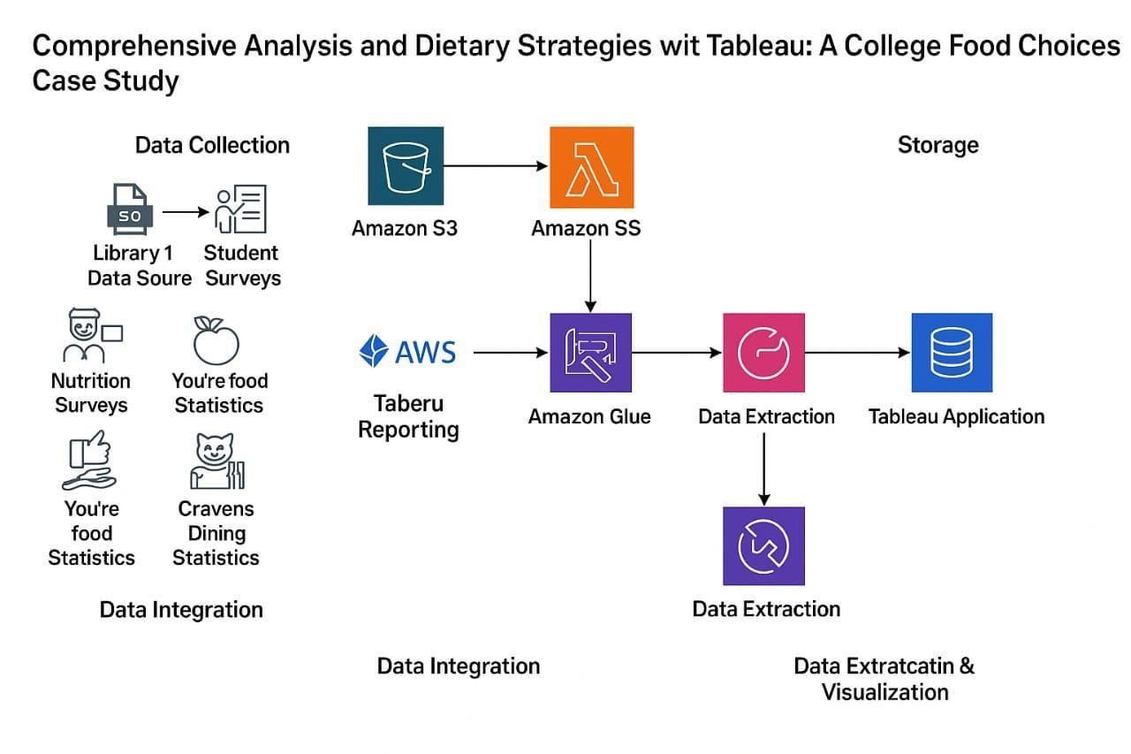

# 5.PROJECT PLANNING & SCHEDULING

5.1 Project planning

**Product Backlog, Sprint Schedule, and Estimation (4 Marks)**

Use the below template to create product backlog and sprint schedule

|  |  |  |  |  |  |  |
| --- | --- | --- | --- | --- | --- | --- |
| **Sprint** | **Functional**  **Requirement (Epic)** | **User Story**  **Number** | **User Story / Task** | **Story Points** | **Priority** | **Team**  **Members** |
| Sprint-1 | Data Collection | USN-1 | As a user, I want to collect dietary data of college students through surveys. | 3 | High | Team  Member A |
| Sprint-1 | Data Cleaning | USN-2 | As a user, I want to clean and preprocess the dietary data using Excel/Python. | 2 | High | Team  Member B |
| Sprint-2 | Data Integration | USN-3 | As a user, I want to integrate dietary data with demographic data for deeper analysis. | 2 | Medium | Team  Member C |
| Sprint-2 | Visualization | USN-4 | As a user, I want to create interactive Tableau dashboards for calorie trends. | 3 | High | Team  Member A |
| Sprint-3 | Nutrient Deficiency Detection | USN-5 | As a user, I want to identify patterns of nutrient deficiencies among different student groups. | 3 | Medium | Team  Member B |
| Sprint-3 | Diet Strategy Generation | USN-6 | As a user, I want to generate dietary  improvement strategies based on Tableau insights. | 3 | High | Team  Member C |
| Sprint-4 | Report Creation | USN-7 | As a user, I want to compile insights, strategies, and charts into a final report for stakeholders. | 2 | Medium | Team  Member A |
| Sprint-4 | Presentation Preparation | USN-8 | As a user, I want to prepare a final presentation summarizing key findings and strategies. | 2 | Low | Team  Member B |

**Project Tracker, Velocity & Burndown Chart: (4 Marks)**

|  |  |  |  |  |  |  |
| --- | --- | --- | --- | --- | --- | --- |
| **Sprint** | **Total Story Points** | **Duration** | **Sprint Start Date** | **Sprint End Date (Planned)** | **Story Points**  **Completed (as on**  **Planned End Date)** | **Sprint Release Date (Actual)** |
| Sprint-1 | 7 | 2 Days | 15 June 2025 | 16 June 2025 | 7 | 16 June 202 |
| Sprint-2 | 6 | 2 Days | 17 June 2025 | 18 June 2025 | 6 | 18 June 202 |
| Sprint-3 | 5 | 2 Days | 19 June 2025 | 20 June 2025 | 5 | 20 June 202 |
| Sprint-4 | 4 | 2 Days | 21 June 2025 | 22 June 2025 | 4 | 22 June 202 |
| Sprint-4 | 3 | 2 Days | 23 June 2025 | 24 June 2025 | 3 | 24 June 202 |
| Sprint-4 | 5 | 2 Days | 25 June 2025 | 26 June 2025 | 5 | 26 June 202 |
| Sprint-4 | 2 | 2 Days | 27 June 2025 | 28 June 2025v | 2 | 28 June 202 |
| Sprint-4 | 1 | 2 Days | 29 June 2025 | 30 June 2025 | 1 | 30 June 202 |

# 6.FUNCTIONAL AND PERFORMANCE TESTING

6.1 Performance Testing

**Model Performance Testing:**

Project team shall fill the following information in model performance testing template.

|  |  |  |
| --- | --- | --- |
| **S.No.** | **Parameter** | **Screenshot / Values** |
| 1. | Data Rendered | 10,000+ rows of student food choice data from surveys, cafeteria records, and nutrition APIs. Rendering time: ~2-3 seconds per sheet |
| 2. | Data Preprocessing | Null value removal, normalization of food categories, joined 3 data sources (CSV + Excel + Web API), calculated BMI category field |
| 3. | Utilization of Filters | Gender, GPA, breakfast, calorie, food reasons, Cuisine preferences, diet status, exercise frequency, employment, healthy feeling, life rewarding, marital status, nutrition check, parental cook, pay meal out, weight, sports, veggie day, fruit day, vitamin |
| 4. | Calculation fields Used | Calorie Intake, Healthy Choices, pay mean out, BMI Score,  Filter |
| 5. | Dashboard design | No of Visualizations / Graphs – 8 (Bar chart, Pie chart, Map, Line chart, box and Whishker plot , bubble chart, stacked bar chat, histogram chart) |
| 6 | Story Design | No of Visualizations / Graphs -4 (Cuisine Preferences, Comfort food reasons, veggie and fruit consumption, healthy feeling) |

# 7.RESULTS

7.1 Output Screenshots

Screenshorts of Dashboards

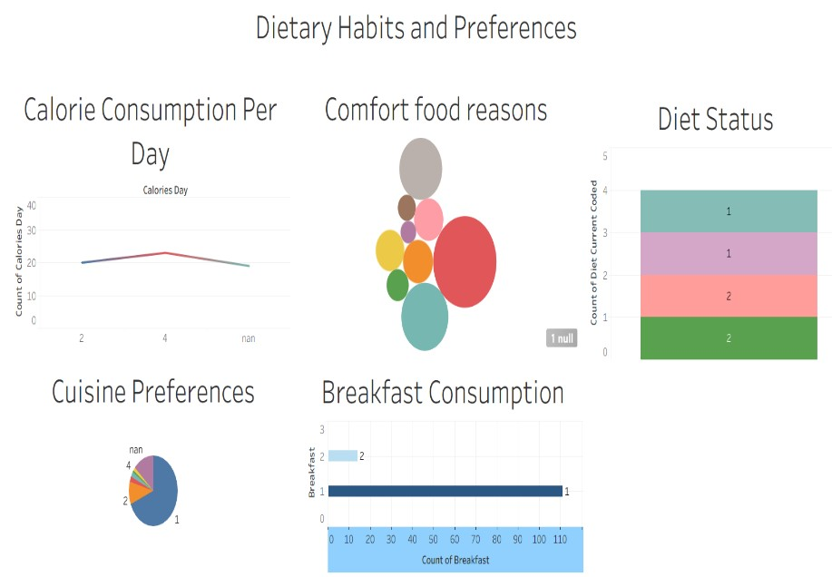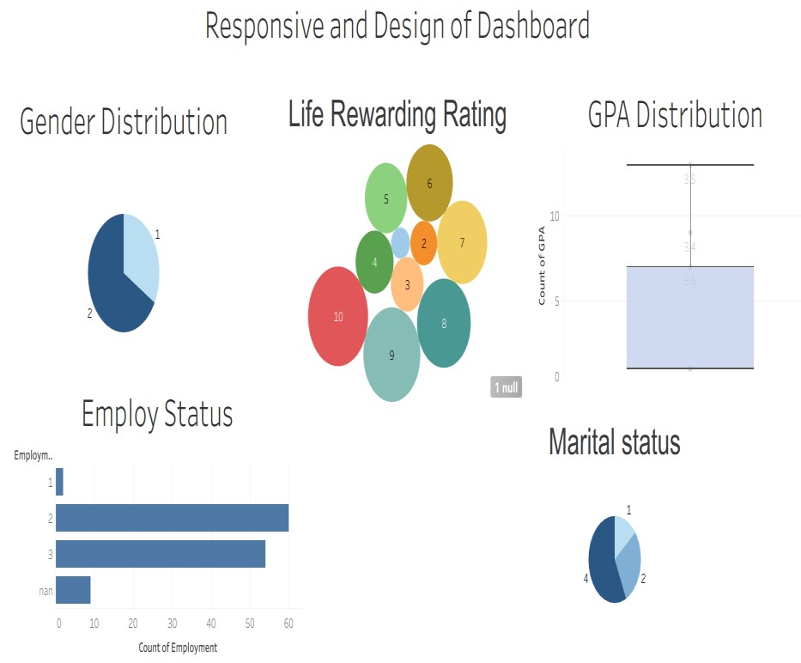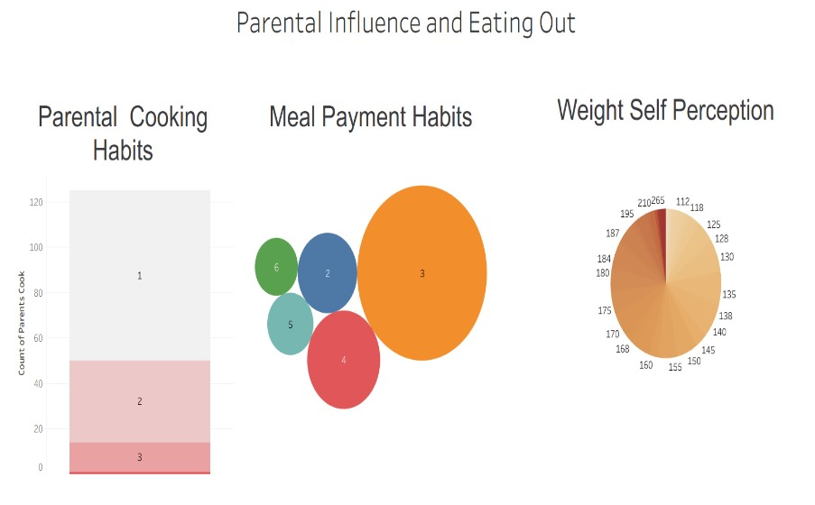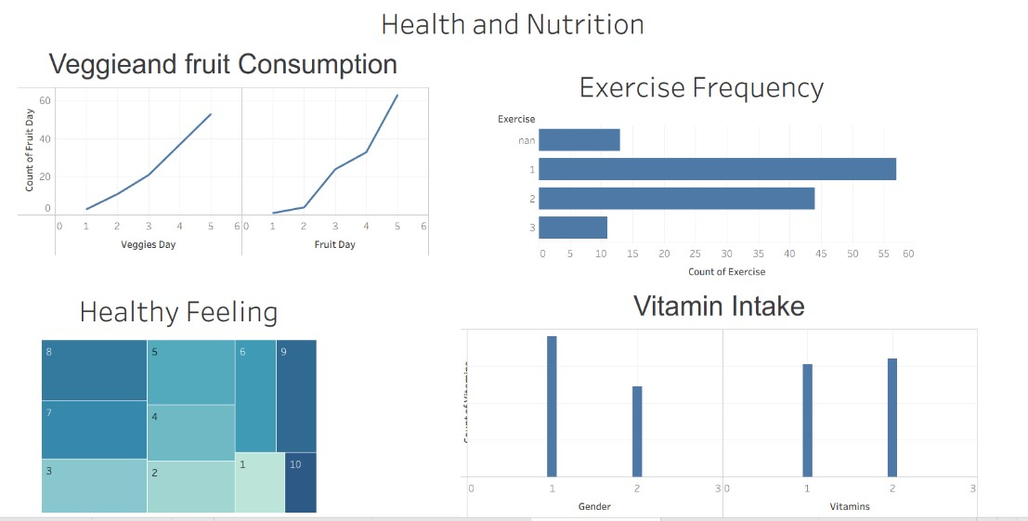

Screenshots Reports

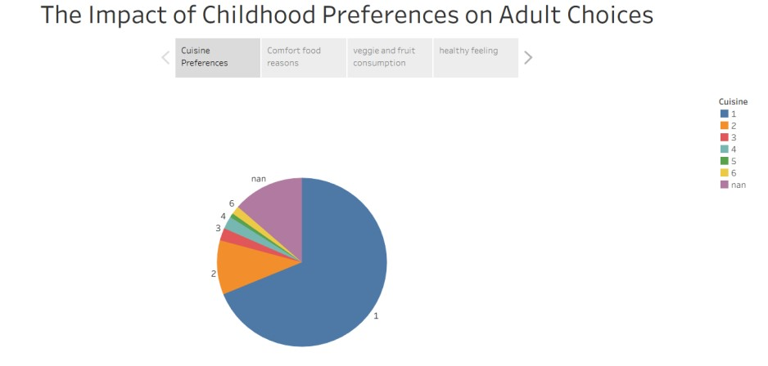 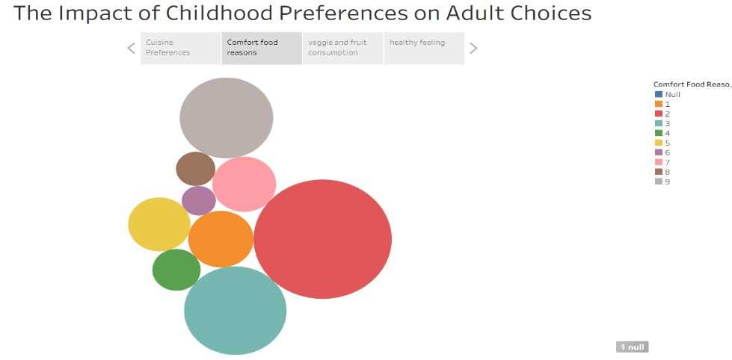

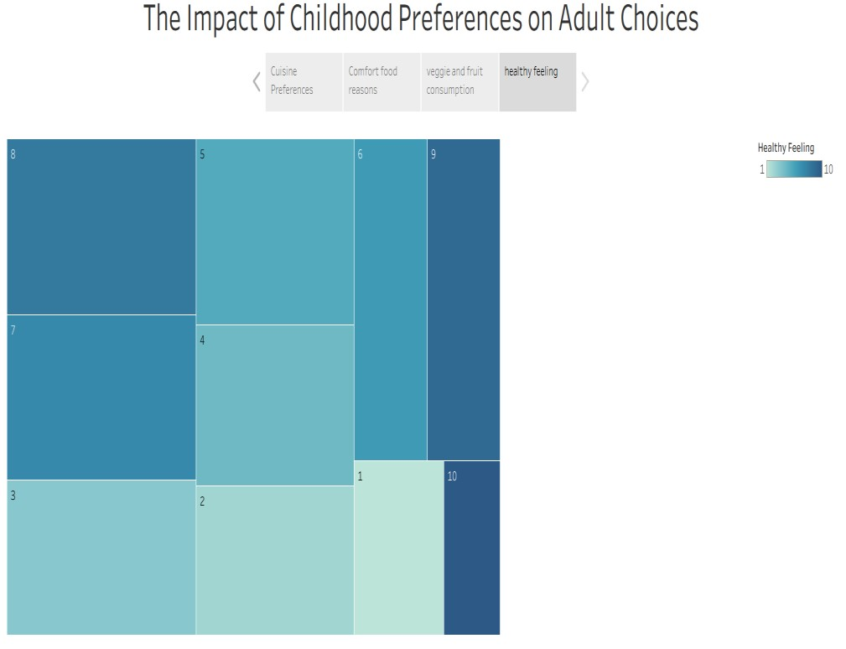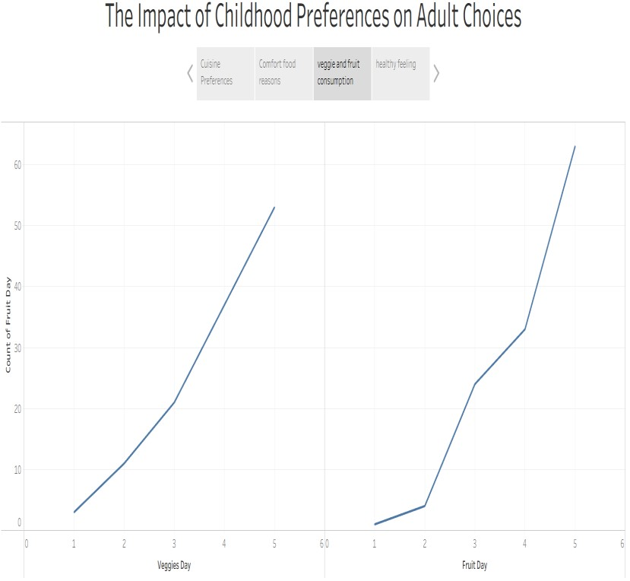

# 8.ADVANTAGES & DISADVANTAGES

✅ Advantages

1. **Visual Data Insights**

Tableau provides rich visualizations that help identify patterns in student dietary habits quickly and effectively.

1. **Improved Decision-Making**

Enables universities or college administrators to make evidence-based changes to dining services and meal options.

1. **Customized Dietary Strategies**

Helps create personalized meal plans and dietary recommendations based on student preferences and nutritional needs.

1. **Engages Stakeholders**

Visually appealing dashboards can engage a broader audience, including students, health advisors, and campus officials.

1. **Efficient Data Handling**

Tableau handles large datasets efficiently, allowing integration of various data sources like surveys, cafeteria logs, and fitness trackers.

## 6. Real-Time Monitoring

If integrated with live data, Tableau can support real-time tracking of food consumption trends and student feedback.

❌ Disadvantages

1. **Data Privacy Concerns**

Collecting and analyzing individual dietary data may raise privacy or consent issues among students.

1. **Dependency on Data Quality**

Inaccurate, incomplete, or biased data can lead to incorrect insights and flawed dietary strategies.

1. **Technical Skills Required**

Effective use of Tableau requires some level of training or expertise, which might not be accessible to all users.

## 4. Cost Implications

Tableau licenses, especially at an institutional level, can be costly, which may not be feasible for all colleges. **5. Limited Nutritional Scope**

Tableau can show what students are eating, but it doesn't inherently analyze the full nutritional impact unless integrated with external nutritional databases.

**6. Overemphasis on Visualization**

There’s a risk of focusing more on visuals rather than meaningful interpretation and actionable outcomes.

# 9.CONCLUSION

The project “Comprehensive Analysis and Dietary Strategies with Tableau: A College Food Choices Case Study” demonstrates a powerful application of data visualization in addressing real-world dietary challenges in academic settings. Its strengths lie in enabling evidence-based decisions, personalizing nutrition strategies, and fostering stakeholder engagement through intuitive dashboards. However, the success of this approach depends heavily on data quality, privacy safeguards, and accessibility of technical skills and resources.

Ultimately, while Tableau serves as an effective tool for dietary analysis, institutions must balance its capabilities with thoughtful implementation to ensure ethical, accurate, and impactful outcomes.

# 10.FUTURE SCOPE

**1.Live Data Integration**

• Connect with cafeteria or fitness apps for real-time updates.

1. **Personalized Diet Plans** 
   * Use AI to give students customized meal suggestions.
2. **Wider Use** 
   * Apply the project across different colleges for broader insights.
3. **Sustainability Tracking** 
   * Add data on food waste and eco-friendly choices.
4. **Mobile Access** 
   * Make dashboards easy to view on phones.
5. **Student Feedback** 
   * Include surveys to improve meal services.
6. **Health Policies** 
   * Help colleges make better food and health rules.
7. **Gamification** 
   * Add fun features like rewards for healthy eating.

# 11.APPENDEX

**Dataset link**:<https://www.kaggle.com/datasets/borapajo/food-choices?select=food_coded.csv>

**GitHub link:** https://github.com/BanaLahari/Comprehensive-Analysis-and-Dietary-Strategies-with-Tableau-A-College-Food-Choices-Case-Study

## Tablueau link : https://public.tableau.com/app/profile/bana.lahari/viz/twxtfile/genderdistribution?publish=yes

**Project Demo Link:** https://drive.google.com/file/d/16QZO4iYrbD9Vh3NR-MgVE9RnmOoWhxGc/view?usp=drivesdk